 | IQVIATM Work Instruction  Global Regulatory Affairs – Application for the US and EU Orphan Drug Designation
Document Number and Revision:
CS_WI_RA0299 Revision 2
Document Owner:  Anja De Pauw | Author(s):  Sruthi Nandikonda

- PURPOSE
To standardize preparation of applications for orphan drug designation (ODD) to be submitted to the Food and Drug Administration (FDA) and to the European Medicines Agency (EMA) to the Committee of Orphan Medicinal Products (COMP).

- SCOPE
This work instruction (WI) applies to all staff delivering ODD applications.

- ROLES AND RESPONSIBILITIES
The following roles perform tasks described within this WI:

Role | Sections
Regulatory Affairs Project Manager (RPM) | 6.1, 6.2
Regulatory Affairs Writer (RAW) | 6.1, 6.4, 6.5
Applicant | 6.1, 6.3
Regulatory Affairs Quality Control Reviewer (RAQCR) | 6.1
An individual can have more than one responsibility. A RPM can perform the role of RAQCR. However, a RAW cannot review work that he/she has prepared and therefore cannot be both RAW and RAQCR for the same deliverable.

- DEFINITIONS
Not Applicable

- TOOLS AND RESOURCES
Not Applicable

- PROCEDURE
Refer to Appendix A for the workflow overview of the ODD procedure.

  - Preparatory Activities
These activities are performed after the contract is finalized, and the project team is assigned.

No: | Who: | Step: | When:
6.1.1 | RPM | If the submission of the ODD request is included in the Statement of Work:  - For the United States of America (USA): Confirms the team member (Applicant) can create a compact disk (CD) and has a printer (for submissions to the FDA).  - For the European Union (EU):  - Confirms the team member (Applicant) has an active EMA user account and is registered as the Orphan Industry Administrator/Manager with the EMA on behalf of any IQVIA office based in the EU (IRIS guide to registration) with an IRIS user access role. Confirms that an appropriate legal agreement is in place for IQVIA to serve as a formal EU ODD holder for customers who are not registered with the EMA and IRIS, or customers who do not have legal entity or a legal person in EU. | At project award
6.1.2 | RPM | - Confirms availability of Project Folder on applicable shared drives, such as REGOPS drive and/or a data room (refer to CS_WI_RA0273 Global Regulatory Affairs – Project Management of Standalone Projects).  - Creates a new customer folder and data room, if applicable, to share documents with the customer. | After the project code is activated
6.1.3 | RPM | - Reviews source documents received from the customer for information gaps.  - Performs a literature search, if necessary.  - Communicates any information gaps to the customer in writing.  - Formulates and documents the regulatory approach and strategy for the application in the Project Folder as per CS_WI_RA0273. | After the project code is activated and after receipt of source documents
6.1.4 | RPM | - Schedules a project initiation (kick-off) meeting with the customer as per CS_WI_RA0273 with the objectives to:  - obtain approval of the proposed regulatory strategy  - obtain agreement on the timetable for preparation of the ODD application and confirm the number of drafts (based on the Statement of Work; usually two). | After the initial background information is received and reviewed
 |  | - Documents the agreements in the meeting minutes, shares the minutes with the customer and archives in the project folder as per CS_WI_RA0273.
6.1.5 | RPM | Schedules QC and works with GRA team to assign a RAQCR per CS_WI_RA0273. | After the timetable is agreed upon

  - Preparation and QC of the ODD application

No: | Who: | Step: | When:
6.2.1 | RAW | - Prepares the ODD application by using the applicable template:  - CS_TP_RA0302 Global Regulatory Affairs – Orphan Drug Designation template for FDA submission  - EMA ODD templates: the current version should be taken directly from https://www.ema.europa.eu/en/human- regulatory/research-development/orphan- designation/applying-orphan-designation#).  - Coordinates the preparation of mandatory translations as applicable in EU. The Customer can use their own translating agency but if in scope for IQVIA refer to CS_WI_RA0262 (Global Regulatory Affairs - Translation of documents). | During project execution, preparation of the deliverable
6.2.2 | RAW | - Uploads PDFs of all the referenced publications in a Project Folder on applicable shared drives, such as REGOPS drive and/or a data room (refer to CS_WI_RA0273 Global Regulatory Affairs – Project Management of Standalone Projects).  - Orders Copyright Clearance for the publications to be shared with the Agency. IQVIA library provides these services as a pass-through cost to the customer. | During of the ODD preparation
6.2.3 | RAQCR | Performs a Scientific QC of Draft 1 of the ODD application and records any review findings in CS_TP_RA0295 Global Regulatory Affairs - Quality Control (QC) Checklist in accordance with CS_WI_RA032 Global Regulatory Affairs - Preparation, Quality Control and Provision of Regulatory Affairs Deliverables. | After Draft 1 has been prepared
6.2.4 | RAW | Makes amendments to Draft 1 per the Scientific QC findings. | During the finalization of the ODD application
6.2.5 | RPM | Sends Draft1 to the customer and obtains feedback.  - Encourages the customer to consolidate all comments in a single document in the returned draft.  - Documents any verbal discussions (phone calls) during the review of Draft 1 and notes the specific corresponding amendments to the ODD in the subsequent drafts.
6.2.6 | RAW | Prepares Draft 2 per the customer’s feedback and sends to the customer. Steps 6.2.5 and 6.2.6 are repeated if:  - Additional amendments are requested by the customer and  - It is consistent with the contractual obligations.
6.2.7 | RAQCR | Performs an Administrative QC of the final (approved by the customer) draft as per CS_WI_RA032 Global Regulatory Affairs - Preparation, Quality Control and Provision of Regulatory Affairs Deliverables.
6.2.8 | RAW | Prepares a final clean ODD application per the Administrative QC findings and maintains all the review cycle comments of all the versions in accordance with CS_WI_RA032 Global Regulatory Affairs - Preparation, Quality Control and Provision of Regulatory Affairs Deliverables.

No: | Who: | Step: | When:
6.2.9 | RAW | For the FDA ODD application, the following letters are required:  - Prepare the Cover letter (CL). An example is provided in Appendix B.  - If the customer is US based, the CL is prepared using the customer’s letterhead, and the customer’s contact information is provided to the Office of Orphan Products Development (OOPD) for further communications.  - If the customer is a foreign entity, IQVIA assumes the role of the US agent for the purpose of this ODD submission. In this case an Authorization to Submit form is executed (Appendix C).  - Self-Certification Letter, i.e. Certification Amendment, (Appendix D) is to be signed either by the US based customer or by IQVIA on behalf of the foreign customer.  For the EMA application, the following letters are required:  - No cover letter applicable. Instead, a form to be completed online via the portal.  - No letter of authorization needed. Instead, proof of establishment of the sponsor/ODD holder is provided in an EE country. | During the ODD preparation

  - Submission of the ODD application
ODD requests are submitted on behalf of the customer if included in the contract. The appropriate submission guidelines can be found on the Agencies’ websites:

https://www.ema.europa.eu/en/human-regulatory/research- development/orphan-designation/applying-orphan-designation#

https://www.fda.gov/industry/designating-orphan-product-drugs-and-biological- products/corresponding-oopd-drug-designation-programs

No: | Who: | Step: | When:
6.3.1 | RPM | Obtains written confirmation from the customer that the final clean draft is approved for submission and archives the confirmation in the project documentation. | Upon delivery of the Final Draft to the customer
6.3.2 | Applicant | - Prepares and mails the submission package to the OOPD per the FDA guidelines.  - Submits EU ODD requests via EMA IRIS platform through IQVIA’s or through company’s access to IRIS, as agreed, and per EMA guidelines (https://iris.ema.europa.eu/). | Upon receipt of the Final customer approved versions

  - Post Submission Activities - FDA Applications
Upon receipt of the ODD request, the OOPD reviews applications within an indicated 90- day period. Usually there is no communication with the OOPD during this period. However, there may be instances when the reviewer will reach out to the RPM with a request for minor clarifications. The “Award” letter or the “Abeyance” letter is expected to be sent to the contact listed in the CL via email. In case IQVIA is submitting on behalf of the non-US customer, IQVIA continues to serve as a US agent for the customer for the purpose of the ODD maintenance.

No: | Who: | Step: | When:
6.4.1 | RPM | Transmits all correspondence from the FDA to the customer. | Post-submission to FDA
6.4.2 | RPM | Verifies if a separate contract is required for FDA ODD annual reports as these activities may or may not be covered by the original contract | Post-submission to the FDA
6.4.3 | RPM | - Verifies that FDA ODD annual reports on development provides information on the status of the development of the medicine.  - Submits FDA ODD annual reports on development via email as detailed at https://www.fda.gov/industry/designating- orphan-product-drugs-and-biological-products/corresponding- oopd-drug-designation-programs . | Post-submission to the FDA, annually, within two months following the anniversary of the designation grant until the Marketing Authorization Application (MAA) is validated, or subsequently upon a specific FDA request

  - Post Submission Activities – EMA Applications
The ODD requests are submitted through the IRIS portal. The deadlines for submission of applications for orphan medicinal product designation to the EMA and corresponding COMP timetable for valid applications can be found at https://www.ema.europa.eu/en/human-regulatory/research- development/orphan-designation/applying-designation/submission-deadlines- orphan-designations.
The evaluation process has a fixed duration of 90 days which includes a validation step. All communications between the applicant and the agency are conducted via IRIS. When IQVIA submits the ODD request through IQVIA registration to the IRIS platform on behalf of the non-EU customer, IQVIA is listed as the holder of this ODD.
The COMP will issue an opinion that will be sent to the ODD holder through IRIS, and a hard copy of the final European Commission Decision will be sent to the ODD holder by courier.

No: | Who: | Step: | When:
6.5.1 | RPM | Notifies the customer in a timely manner about all the correspondence received from the ODD | Post-submission to the EMA
6.5.2 | RPM | Verifies if a separate contract is required for EU ODD annual reports as these activities may or may not be covered by the original contract | Post-submission to the EMA
6.5.3 | RPM | - Verifies that the EU ODD annual reports on development provide information on the status of the development of the medicine.  - Submits EU ODD reports on development annually via the IRIS portal Annual reports are submitted via IRIS portal.  Note: At the time of the MAA submission to EMA, a report on the maintenance of orphan designation criteria is requested. | Post-submission to EMA, annual, within two months following the anniversary of the designation grant (EC Decision) until the MAA is validated, or subsequently upon a specific EMA request

- SUPPORTING DOCUMENTATION

DOCUMENT NUMBER | TITLE
ESOP References
7.1 CS_WI_RA032 | Global Regulatory Affairs – Preparation, Quality Control and Provision of Regulatory Affairs Deliverables
7.2 CS_TP_RA0295 | Global Regulatory Affairs – Quality Control (QC) Checklist
7.3 CS_WI_RA0273 | Global Regulatory Affairs – Project Management of Standalone Projects
7.4 CS_TP_RA0302 | Global Regulatory Affairs – Orphan Drug Designation template for FDA submission
7.5 CS_WI_RA0262 | Global Regulatory Affairs – Translation of documents
External References
7.6 Applying for orphan designation in the EU | https://www.ema.europa.eu/en/human-regulatory/research- development/orphan-designation/applying-orphan- designation#
7.7 Applying for orphan designation in the US | https://www.fda.gov/industry/developing-products-rare- diseases-conditions/designating-orphan-product-drugs-and- biological-products

- SUPERSEDES

DOCUMENT NUMBER | TITLE | REVISION NUMBER
8.1 CS_WI_RA0299 | Global Regulatory Affairs – Application for the US and EU Orphan Drug Designation | 1

- MODIFICATION FROM PREVIOUS REVISION

CHANGE | SECTION REFERENCE | JUSTIFICATION
Renamed role RAM to RPM | Section 3 and 6 | To be consistent with other GRA work instructions
Updated requirements for EMA applications | 6.2.9

- APPENDICES

  - Appendix A: Process workflow

  - Appendix B: Example of Cover letter (for FDA ODD submission)

  - Appendix C: Example of Authorization to submit letter (for non-US customer FDA ODD submission)

  - Appendix D: Example of Self-sertification amendment (for FDA ODD submission)

 | Document Title:  Global Regulatory Affairs – Application for the US and EU Orphan Drug Designation
Document Number and Revision:
CS_WI_RA0299 Revision 2

Appendix A: Process workflow
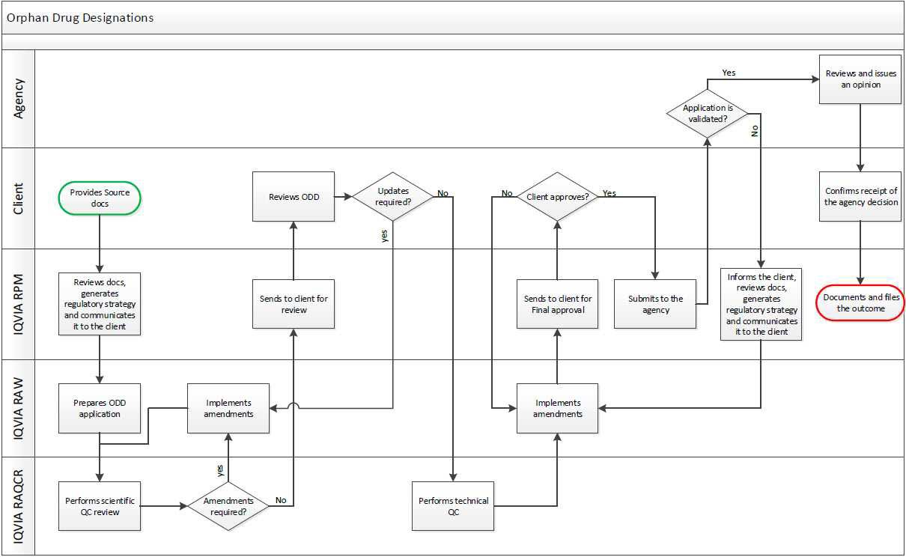

Page 8 of 11
Copyright © 2020, 2022. IQVIA. All rights reserved. The contents of this document are confidential and proprietary to IQVIA Holdings Inc. and its subsidiaries. Unauthorized use, disclosure or reproduction is strictly prohibited.
UNCONTROLLED COPY CS_WI_RA0299 Revision 2 - EFFECTIVE on 01-Jul-2022

Appendix B: Example of Cover letter (for FDA ODD submission)
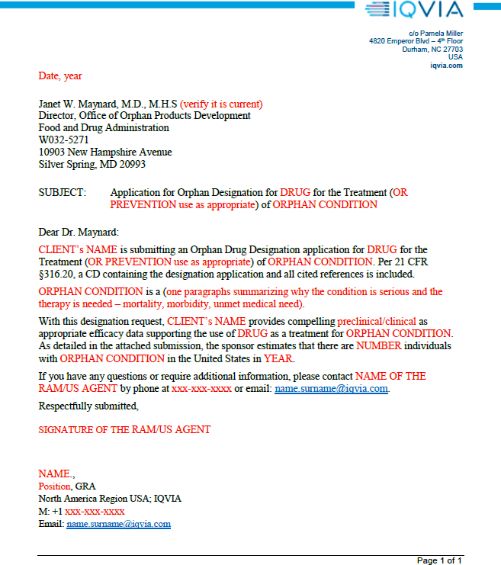

Appendix C: Example of Authorization to submit letter (for non-US customer FDA ODD submission)
On client’s letterhead:

AUTHORIZATION TO SUBMIT MATERIALS TO THE FOOD AND DRUG ADMINISTRATION

Month Date, Year

Name of Sponsor: CLIENT’s NAME.
Type of FDA Submission Orphan Drug Designation Application Drug and Indication DRUG for the treatment (or prevention) of
ORPHAN CONDITION
FDA Liaison for the Sponsor: IQVIA, Inc. (RPM Name and Title)

CLIENT’s NAME hereby certifies that RPM Name and Title and any other personnel at IQVIA Inc. (IQVIA) are authorized and entitled to represent the sponsor for purposes of submitting the above-mentioned application to the Food and Drug Administration (FDA) on behalf of sponsor as their FDA Liaison. RPM Name and Title contact information is copied below:
RPM Name and Title, IQVIA,
GRA-North America Region USA-Eastern Time
M: +1 xxx xxx xxxx
F: +1 xxx xxx xxxx
Email: name.surname@iqvia.com

Signature line for the Sponsor (Sponsor is to provide name, position, contact info and the signature of Authorizing person here)

Appendix D: Example of Self-sertification amendment (for FDA ODD submission)
On client’s letterhead:

Date, year

Ilan Irony, M.D (verify it is current)
Acting Director, Office of Orphan Products Development Food and Drug Administration
W032-5295
10903 New Hampshire Avenue Silver Spring, MD 20993-0002

RE: Certification Amendment for Request for Orphan Designation for DRUG for the Treatment (OR PREVENTION use as appropriate) of ORPHAN CONDITION

Dear Dr. Maynard:

Reference is made to the Orphan Drug Designation request DRU-2019-7291 for DRUG for the Treatment (OR PREVENTION use as appropriate) of ORPHAN CONDITION submitted on DATE.

It is hereby certified that CLIENT’s NAME has not previously submitted a marketing application to the FDA for the same active moiety for the same rare disease or condition prior to the submission of this request for orphan drug designation.

If you have any questions or require additional information, please contact RPM/US AGENT or Clients contact info if client is a US based company by phone at xxx-xxx-xxxx or email: name.name@company.com.

Respectfully submitted, Signature and
Name, position, address, contact info

Page 11 of 11
Copyright © 2020, 2022. IQVIA. All rights reserved. The contents of this document are confidential and proprietary to IQVIA Holdings Inc. and its subsidiaries. Unauthorized use, disclosure or reproduction is strictly prohibited.

UserName: Dobrychlop, Karolina (q1025820) Title:
Date: Tuesday, 24 May 2022, 02:19 AM Eastern Daylight Time Meaning: Signing this Document Indicates My Approval
================================================

UserName: Corley, Helen (q730385) Title:
Date: Tuesday, 24 May 2022, 03:02 AM Eastern Daylight Time Meaning: Signing this Document Indicates My Approval
================================================

UserName: Lewicky, Tamara (q730348) Title:
Date: Tuesday, 24 May 2022, 04:08 AM Eastern Daylight Time Meaning: Signing this Document Indicates My Approval
================================================

UserName: NAJI, Kenza (u1090913) Title:
Date: Tuesday, 24 May 2022, 11:18 AM Eastern Daylight Time Meaning: Signing this Document Indicates My Approval
================================================

UserName: Glizer, Veronica (q735279) Title:
Date: Tuesday, 24 May 2022, 01:11 PM Eastern Daylight Time Meaning: Signing this Document Indicates My Approval
================================================

UserName: SENGAR, SATISH (q1036027)
Title:
Date: Wednesday, 25 May 2022, 01:54 AM Eastern Daylight Time Meaning: Signing this Document Indicates My Approval
================================================

UserName: Nandikonda, Sruthi (u1076598) Title:
Date: Wednesday, 25 May 2022, 08:34 AM Eastern Daylight Time Meaning: Signing this Document Indicates My Approval
================================================

UserName: Singh, Priti (q823374) Title:
Date: Monday, 30 May 2022, 04:43 AM Eastern Daylight Time Meaning: Signing this Document Indicates My Approval
================================================

